2015

Database for a Spanish to English Services Company
Vlad Predovic
Fall 2015

Database serving a Spanish to English services company
- Employees: EID, Name, PW, phone number, admin(binary)
- Clients: CID, Client Name, password, Email, phone number, address
- Work: WID, Date requested, Client Name, Date Started, Completion Date, Hrs. Worked
- Job: Job type, Date started, DID
- Service: Service type, Location
- Documentation(files): DID, Description, Media Type, CID, Date received
Introduction:
The database project will support a company that provides services for bridging the gap between English and Spanish speakers. This could be something as simple as translating a document or personal like communicating between a sick patient and their doctor and even developing learning material for non-English speakers. The company provides both jobs and services to its clients, and needs a way to keep track of this. Additionally, long-term clients will have accounts so they can automatically request additional items. The company needs a way to keep track of the many documents being worked on, be able to add and remove users, and keep track of hours worked on a job for all the employees.

Detailed Application Requirements:
The first implementation is a way for employees to see the work being done in table form. This will require some form of login/session-protected page with a table drawing joined values from the database. The table will portray jobs by creation date and have details like who is the ‘lead’ working the job, links to a file attached if applicable, and the status of the job/service to be completed. Additionally the owners of the company want to be able to adjust values themselves such as the time worked on the job, changing current parameters, and adding additional jobs. These user-oriented applications can be done through the implementation of form queries in php.
Another requirement that was decided upon with my sponsors was a way for clients to view the jobs they have requested, those they have completed, and be able to request more work. The issue here is that the company does not want to receive emails from regular clients each time a new job or service is needed. Regulars should have a way to submit work they want done and view their current history. Accounts for each long-term client will be added requiring that they be added to the database as a ‘client’ object. Once logged on a load query and some php code will bring up a table showing the client their history with a form option to add another request.
The company wants to be able to upload and keep track of information. This company will be dealing with documents a lot of the time due to the translating services that are provided. These need to be archived and connected to the rest of the database. The user will have a way to upload a file in relation to each job. Once this is complete, the document will automatically be related to a client, a work date, and a ‘lead’ employee through the implementation of the relational database. However, one of the limitations is the storage capacity of the servers. A work-around in consideration is using an existing system such as the Google Drive or Microsoft’s One Drive to upload files and then providing the URL link to these to be saved into the database. To users a file link would be displayed for the current job that would lead them to where the file that is being worked on is located.

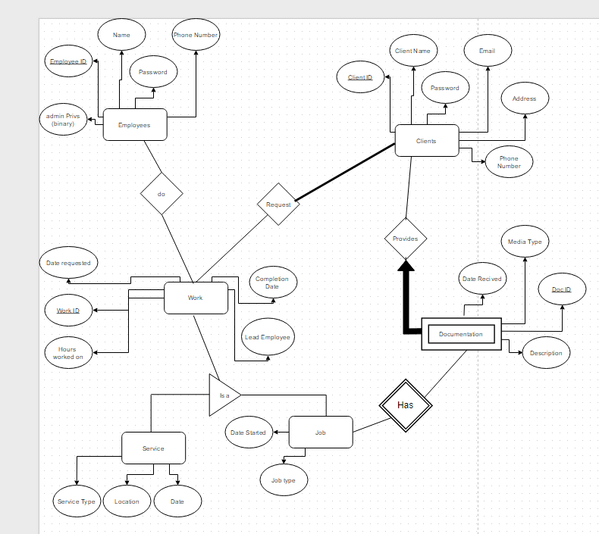

Table to Show Jobs in Work:
Work ID | Date Started | Lead | Client | File | Work Status
3235 | 5/4/2212 | Vlad Pred | BBB LC | www.zzz.com | Incomplete

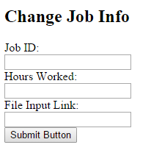
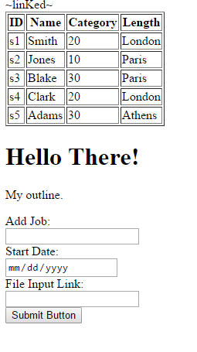
These are the couple of the forms Administrators and clients will be able to use to enter their information. On the left you can add a job along with a start date and a file link. This can be used by clients to enter jobs on their page. On the right an employee can enter values to alter their job info. The client has also requested the ability to query all requests/jobs by a certain employer and that these appear on a separate printable page.

Below is a rough sketch of what the Administration page might look like for an employee:

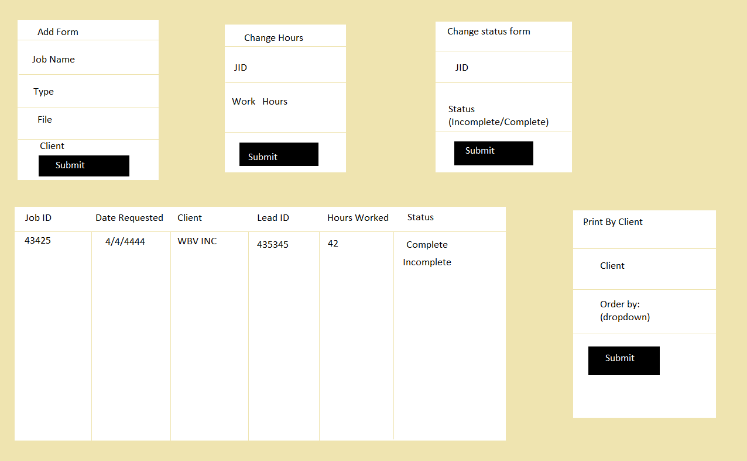

Tables, Entities, and Relations:

Employees (EID: Integer, Name: char (20), password: char (20), PhoneNumber: char (10), adminPrivs: Boolean)
Candidate Keys: EID, PhoneNumber
Work_On (EID: integer, WID: integer, HrsWorked: integer)
Candidate Keys: EID, WID
Foreign Keys: EID, WID
Work (WID: Integer, DateRequested: Date, CompletionDate: Date, LeadID: Integer (10), WorkType:
Char (6), CID: Integer)
Candidate Keys: WID
Foreign Keys: CID
Service (WID: Integer, ServiceType: Char (10), ServiceLocation: Char (50), ServiceDate: Date)
Candidate Keys: WID
Job (WID: Integer, DateStarted: Date, JobType: Char (10), DocID: Integer)
Candidate Keys: WID
Foreign Keys: DocID
Documentation (DocID: Integer, DateRecieved: Date, MediaType: Char (20), Description: Char 50))
Candidate Keys: DocID, Description
Clients (CID: Integer, ClientName: Char (25), Cpassword: Char (20), Email: Char (15), Address: Char (50), Phone: Char (10))
Candidate Keys: CID, ClientName, Email

- CREATE TABLE EMPLOYEES (EID INTEGER, EmpName CHAR(20), Password CHAR(20), PhoneNumber CHAR(10), adminPrivs TINYINT, PRIMARY KEY(EID))

- CREATE TABLE Clients (CID INTEGER, ClientName CHAR(25), Cpassword CHAR(20), Email CHAR(15), Address CHAR(50), Phone CHAR(10), PRIMARY KEY (CID))

- CREATE TABLE Work (WID INTEGER, DateRequested DATE, CompletionDate DATE, LeadEID INTEGER (10), WorkType CHAR(6), CID INTEGER, PRIMARY KEY (WID), FOREIGN KEY (CID) REFERENCES Clients)

- CREATE TABLE Work_On (EID INTEGER, WID INTEGER, HrsWorked INTEGER, PRIMARY KEY (EID, WID), FOREIGN KEY(EID) REFERENCES Employees, FOREIGN KEY(WID) REFERENCES Work)

- CREATE TABLE Service (WID INTEGER, ServiceType CHAR(10), ServiceLocation CHAR(50), ServiceDate DATE, PRIMARY KEY (WID), FOREIGN KEY (WID) REFERENCES Work)

- CREATE TABLE Documentation (DocID INTEGER, DateRecieved DATE, MediaType CHAR(20), Description CHAR(50), PRIMARY KEY (DocID))

- CREATE TABLE Job (WID INTEGER, JobType CHAR(10), DateStarted DATE, PRIMARY KEY (WID), DocID INTEGER, FOREIGN KEY (WID) REFERENCES Work, FOREIGN KEY DocID REFERENCES Documentation)

Relational Algebra for user-driven questions

What service dates are currently scheduled by Client ‘PtMedical’?
πDateRequested((σClientName=“PtMedical”Client) ⋈ Service) ~This is valid because service is a ‘Work’
Provide the ID of documentation available for jobs started in the last 30 days?
πDID((σDateStarted≤ “10/08/2015”Jobs) ⋈ Documentation)
What employees are currently leading a project?
πEmpName((σLeadEID Work) ⋈ Employees)
A listing of the amount of hours Sally Morris worked on jobs requested by PTMedical?
p(R1, πWID((σClientName=“PtMedical”Client) ⋈ Work))
p(R2, R1 ⋈ Works_On ⋈ (σEmpName=“Sally Morris”Employees))
πHrsWorkedR2

HW.5 Table and Data Manipulation

For this part of the project I created a two-section database. The client specified the ability to login as a client as well as an employee. Below I aligned features from logging in as an employee and the difference with logging in as a client:

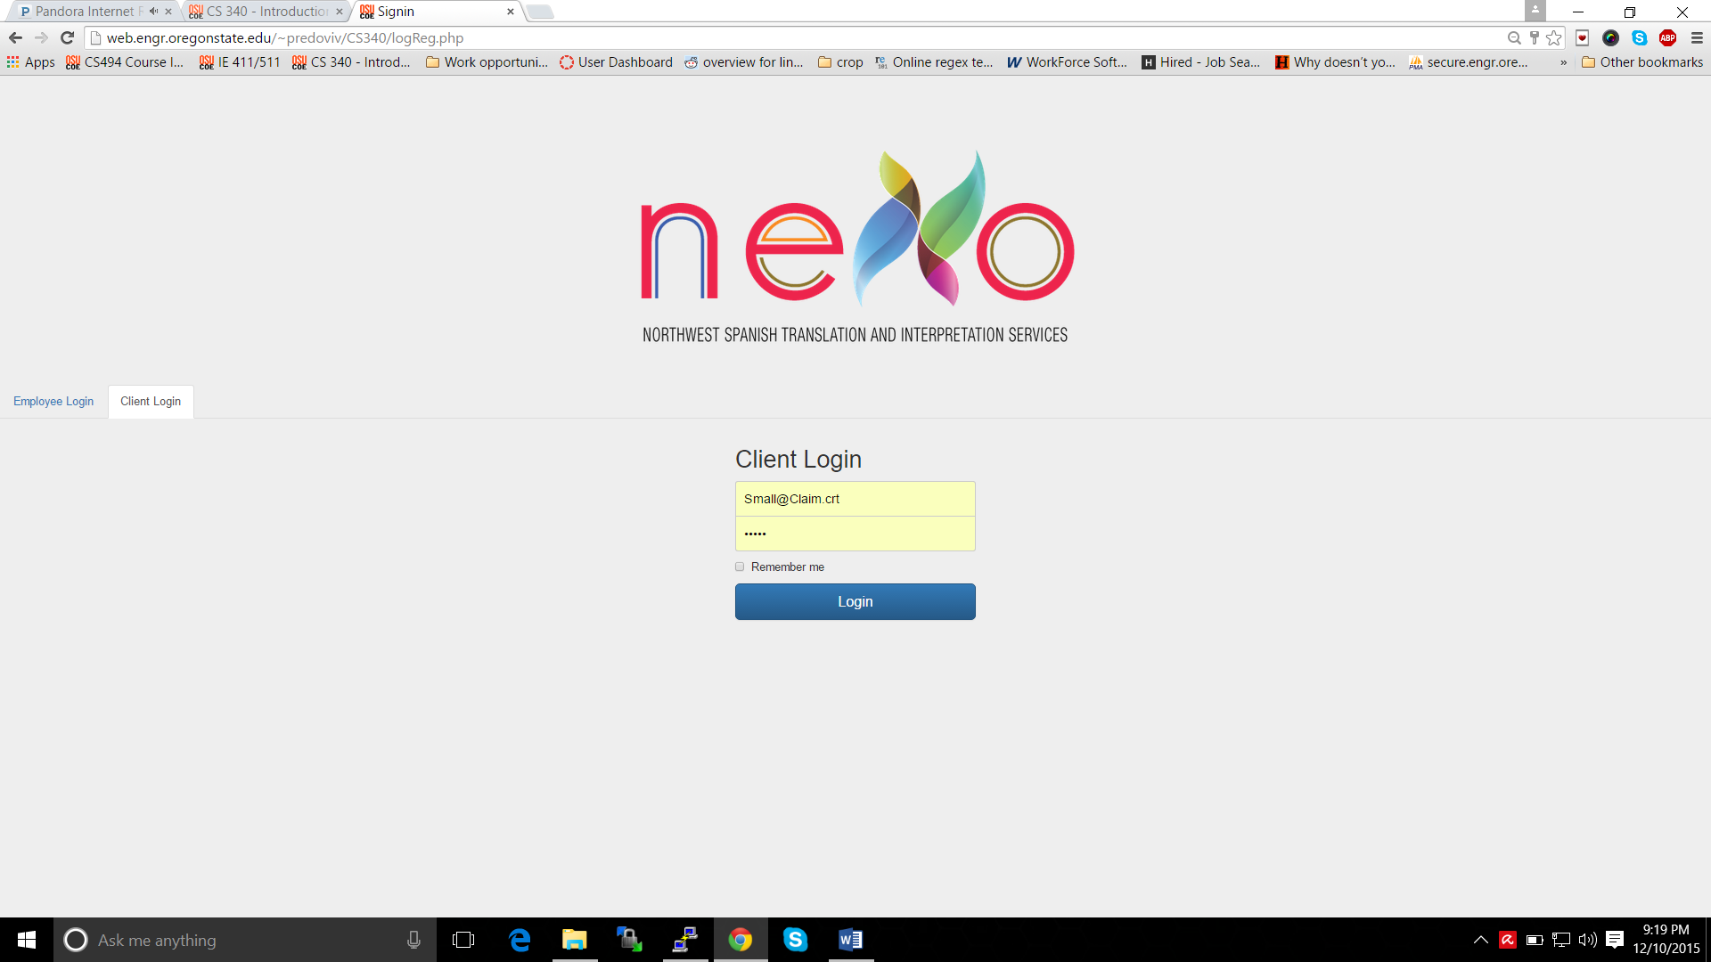
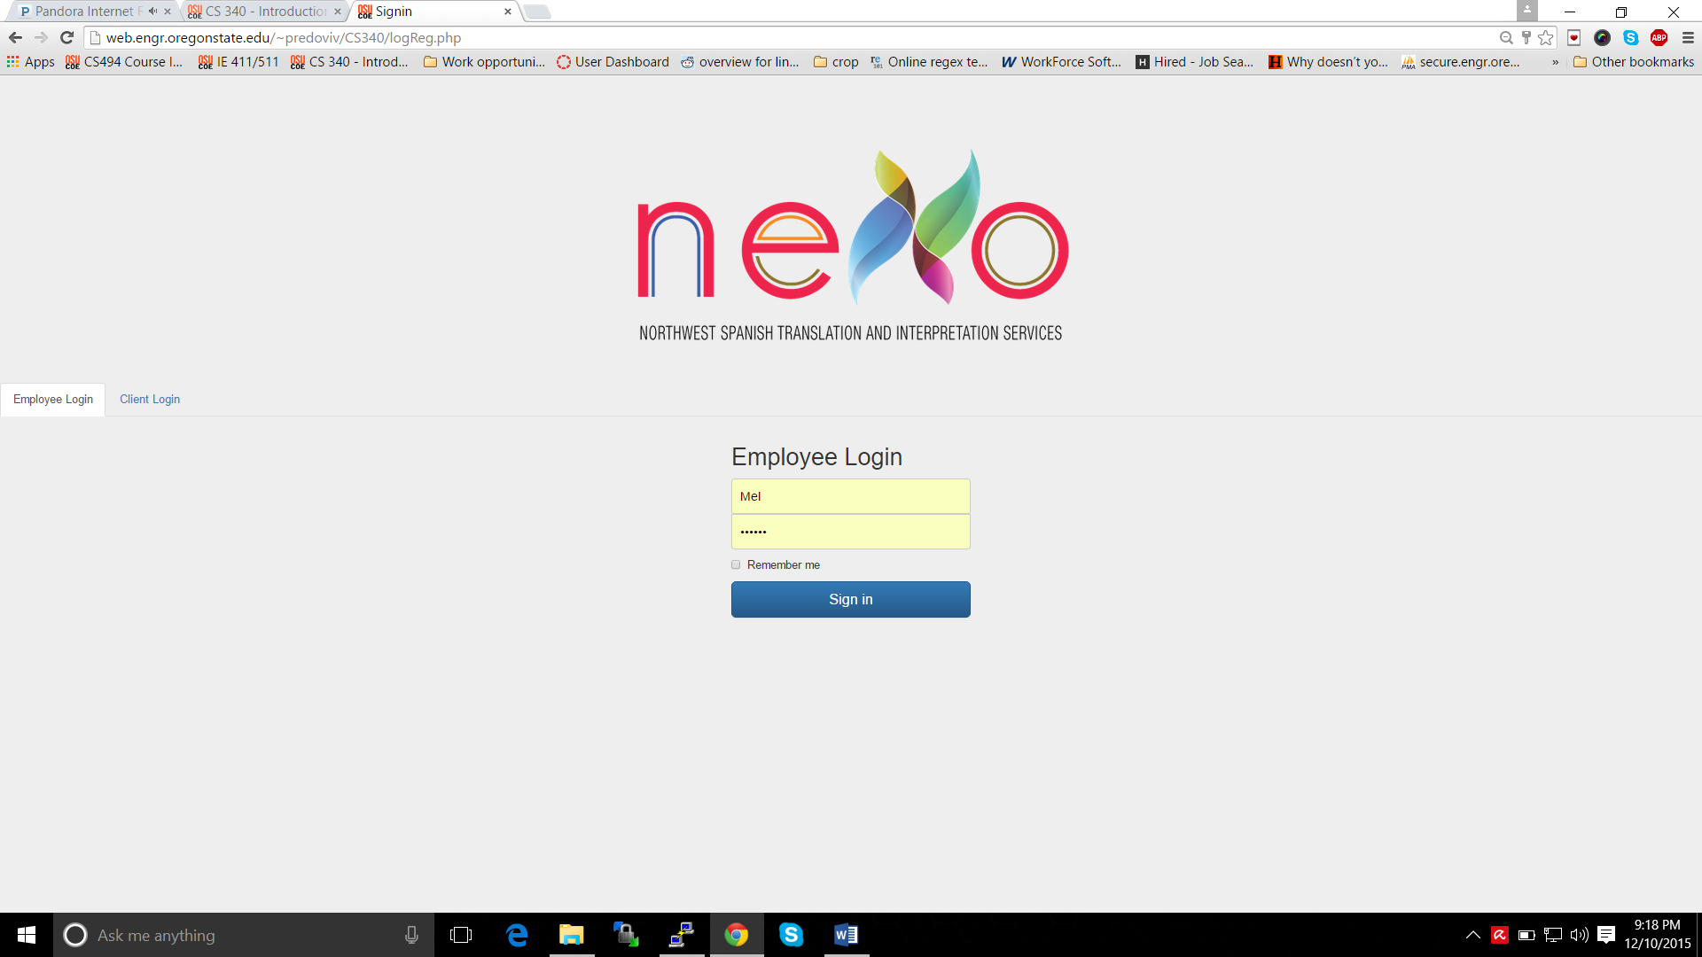

The page featured below shows the basic layout of the employee login page.
You can do things such as add an employee, see the work completed, and remove current employees.
The admin employee can also see any of the current employee’s workloads and edit an employee’s phone number,
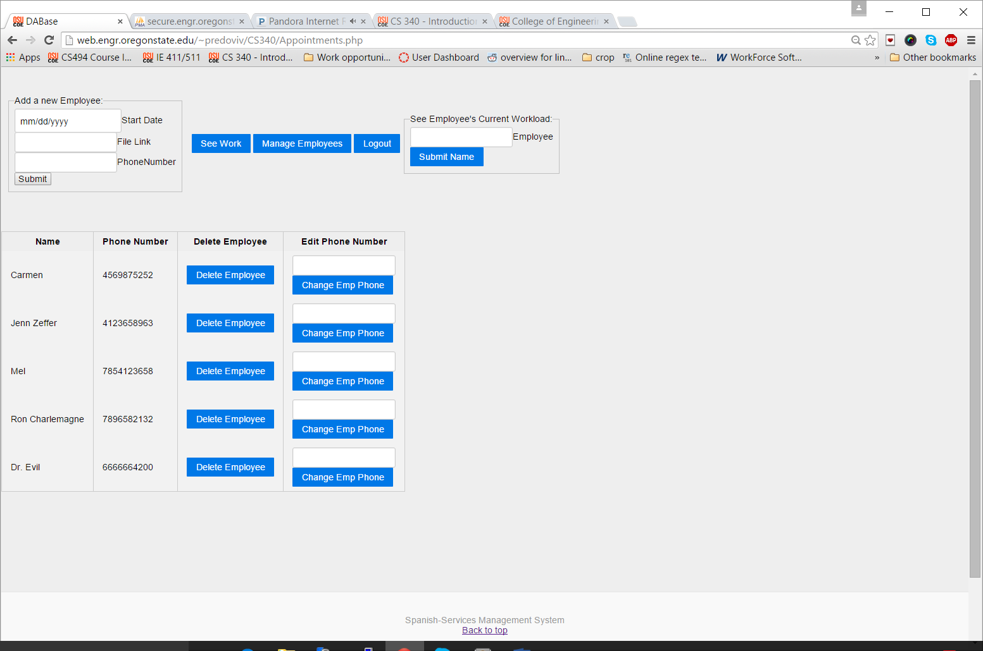

Code used for developing the page above:

Delete Query to remove employees: 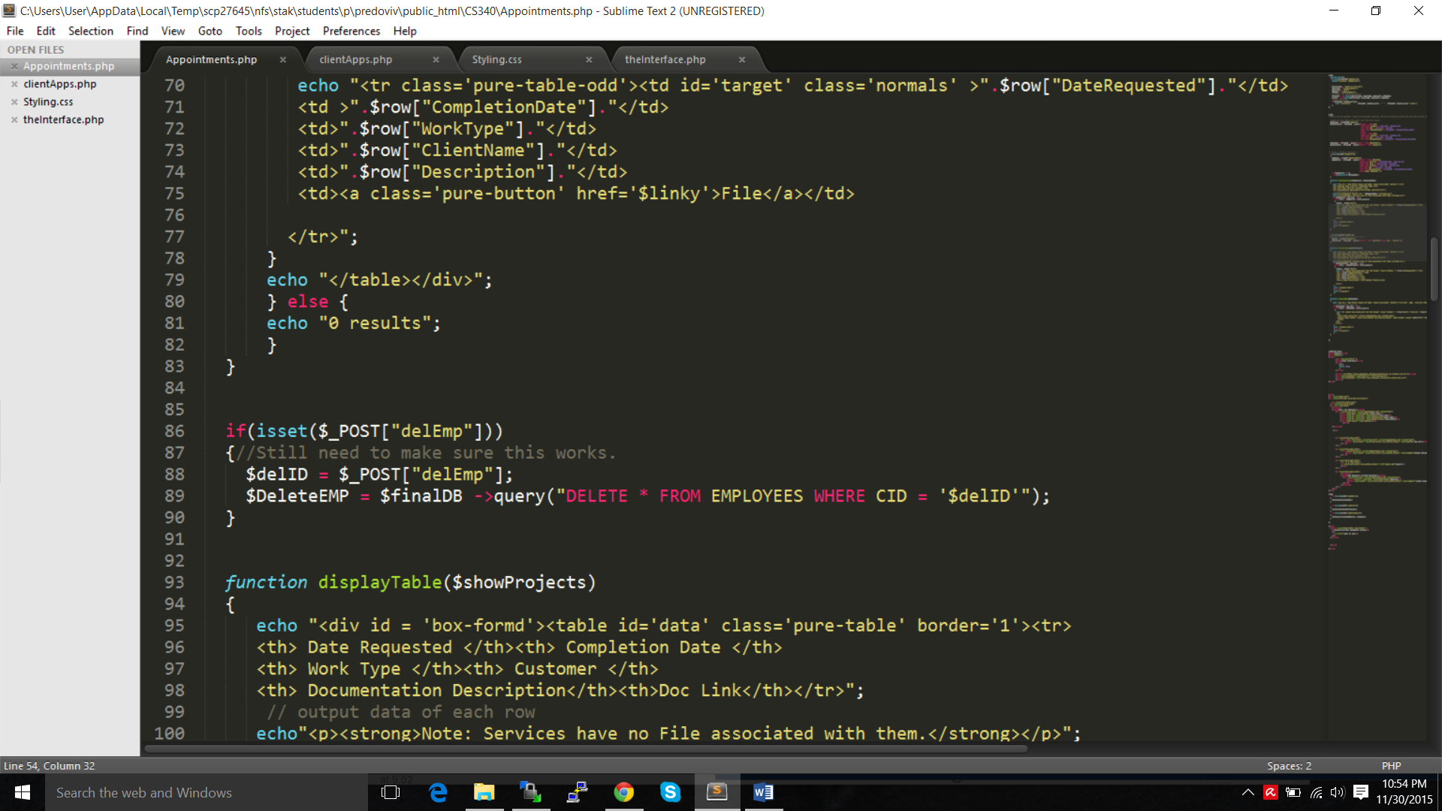

HTML code to delete the Employee exists within a function to create a button for each employee and to alter the phone number of the employee.
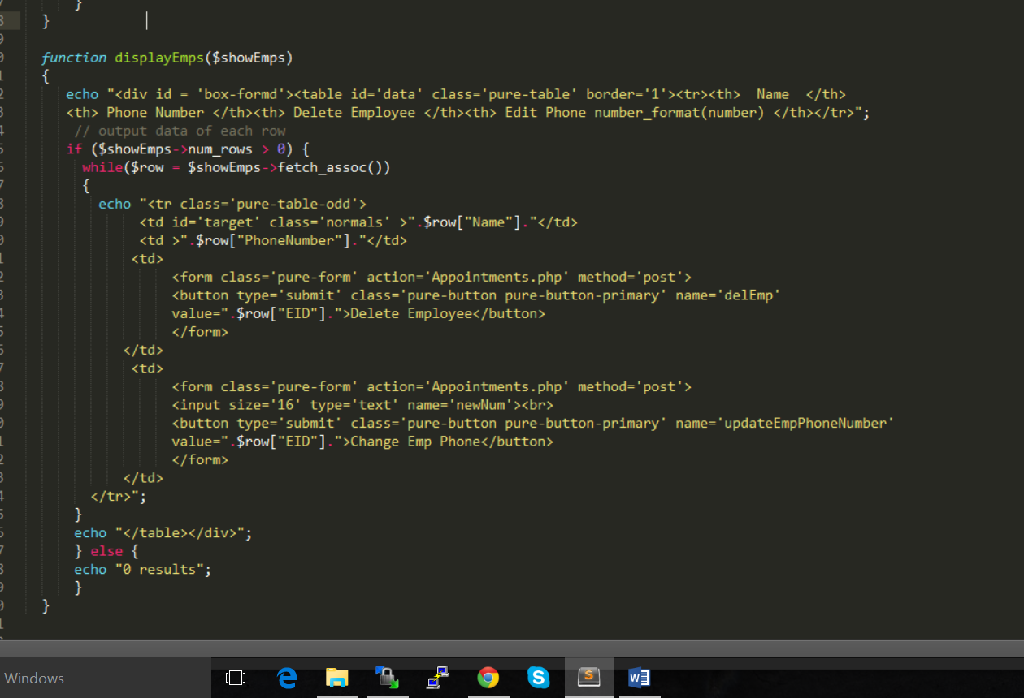

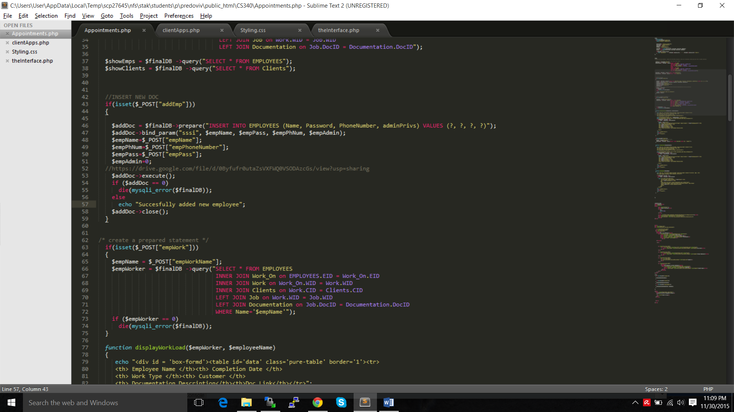
Code to add a new Employee:

Code to Update an Employee Phone Number or Delete given employee:
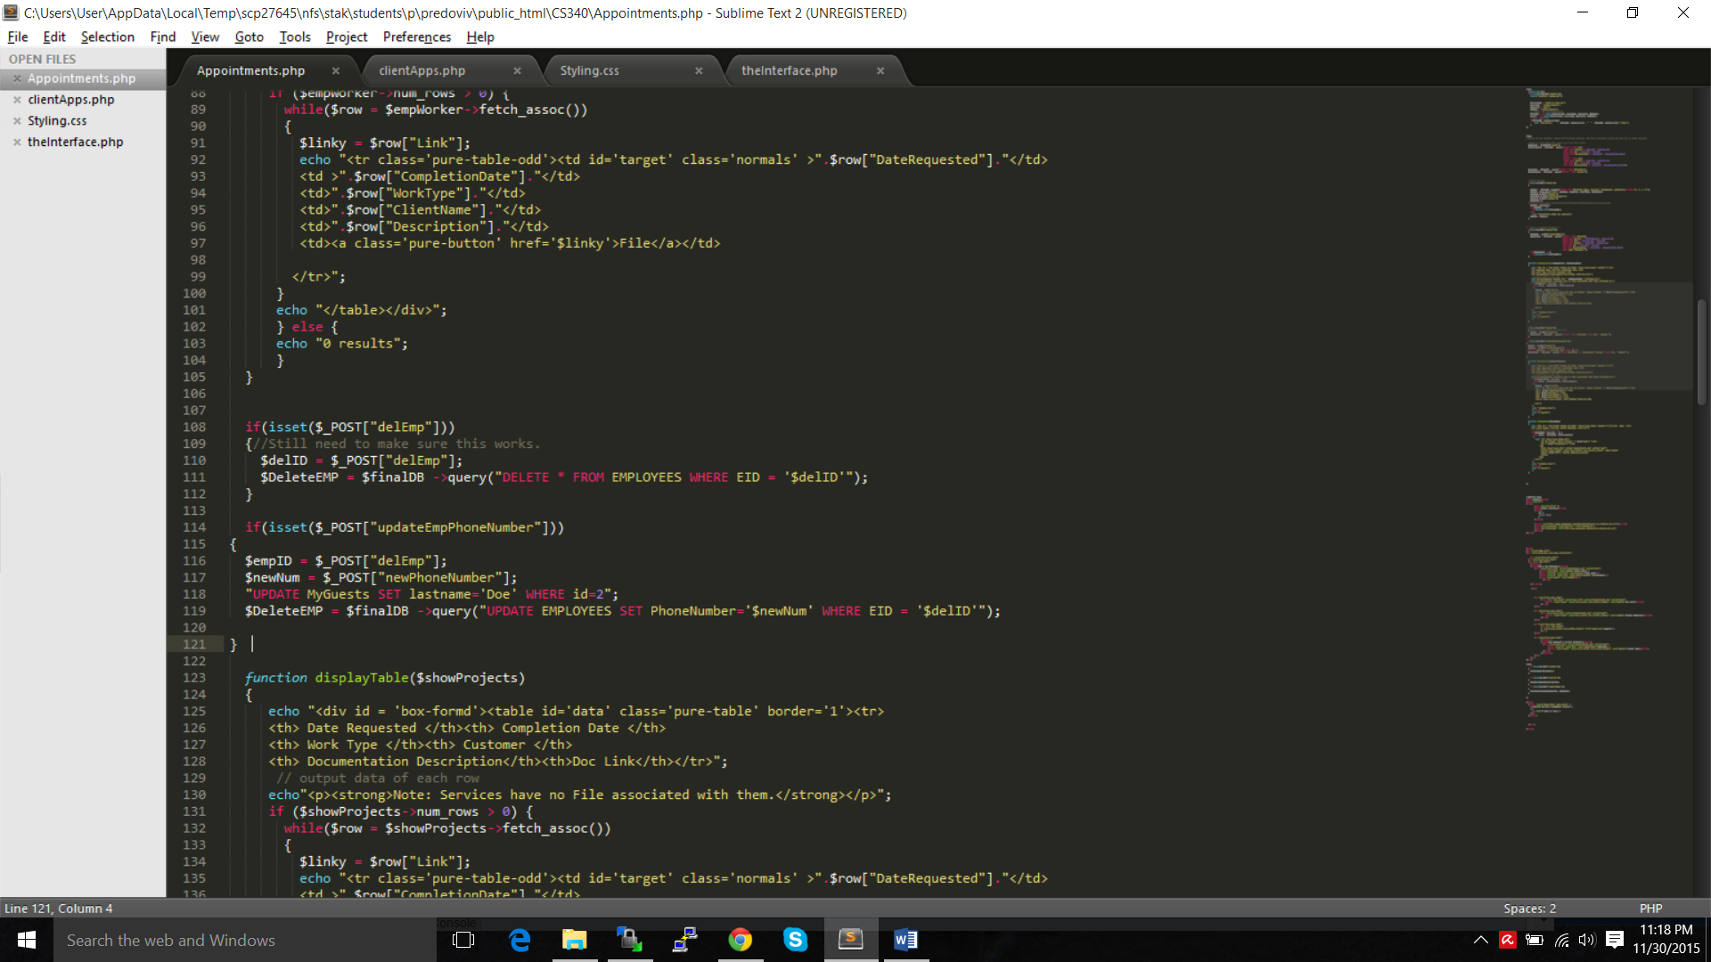

The figure outlined below below represents the command menu and possible options from the employee admistrators login screen. As you can see, for now there are not many options. One of the critical issues regarding my design is that my clients are not tech-savvy, in fact they are very bad with computers.

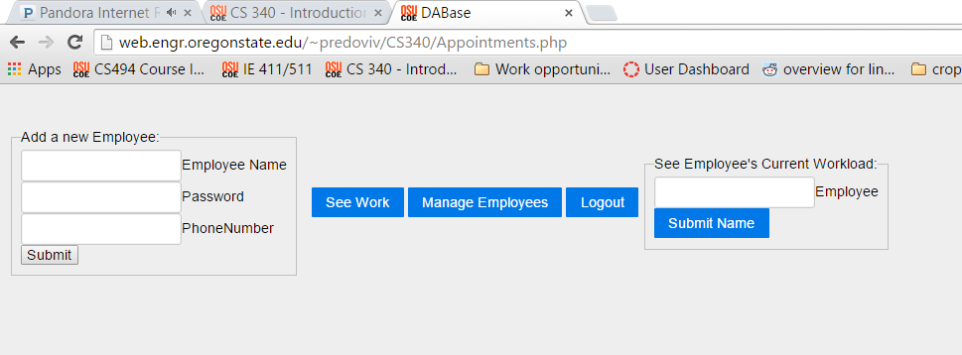

Accesing my Project:

For Employee.
Name = Mel
Password = Gibson

For client
Email = Small@Claim.crt
Pass = SMALL

Link: http://web.engr.oregonstate.edu/~predoviv/CS340/logReg.php

